**SUMMIT SUM-704 DOG GUARD**

**FOOT ASSEMBLY**

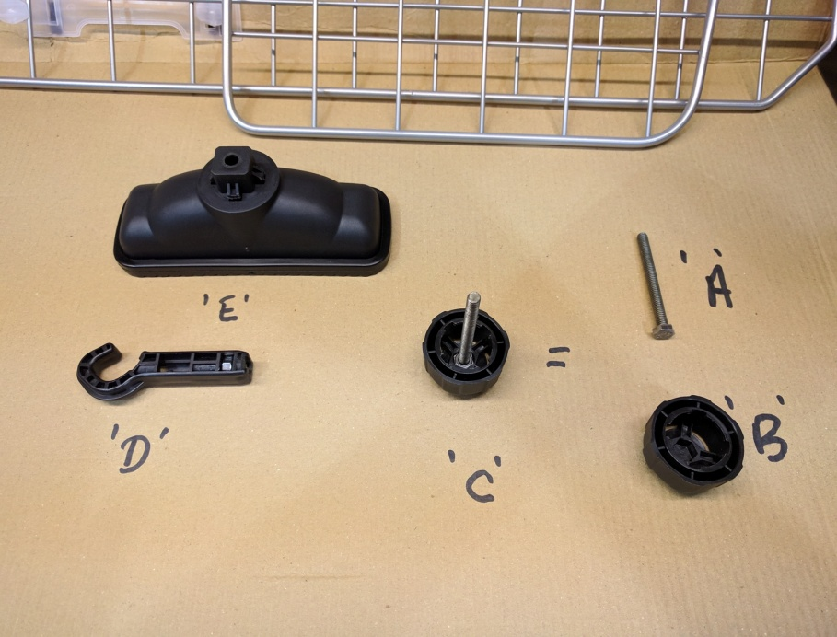

**TAKE BOLT ‘A’ AND LINE UP HEX HEAD WITH HEX CUTOUT INSIDE ‘B’ ADJUSTING HANDLE (YOU MAY NEED TO GIVE A GENTLE TAP TO THE END OF THE BOLT TO MAKE THE HEAD LOCATE SECURELY).**

**NOW ‘A ‘AND ‘B ‘BECOME ‘C ‘THE ASSEMBLED ADJUSTING HANDLE.**

**TAKE ‘C’ AND LOCATE IN TOP OF THE FOOT ‘E’ .PUSH THE HOOK ‘D’ INTO THE LOCATION PORT ON THE OPOSITE SIDE (FLAT SIDE) AND WIND ‘C’ IN UNTIL IT STARTS TO PULL THE HOOK IN.THE HANDLE ‘C’ WILL CLICK AS TURNED.**

**THIS IS NOW READY TO BE USED TO CONNECT TO HEADREST RODS (SEE BELOW).**

